A PROJECT REPORT

on

A Comparative Analysis of Machine Learning Models for
Crop Recommendation System

Submitted to

KIIT Deemed to be University

In Partial Fulfillment of the Requirement for the Award of

BACHELOR’S DEGREE IN

COMPUTER SCIENCE ENGINEERING

BY

ANIK PAUL 22051235
ANKIT RAY 2205535
SUBHADEEP SAHA 2205779
SOUMEN SEKHAR BISWAS 2205777

UNDER THE GUIDANCE OF

Dr. BHABANI SANKAR PRASAD MISHRA



SCHOOL OF COMPUTER ENGINEERING

KALINGA INSTITUTE OF INDUSTRIAL TECHNOLOGY

BHUBANESWAR, ODISHA - 751024

April 2025

KIIT Deemed to be University

School of Computer Engineering
Bhubaneswar, Odisha - 751024

CERTIFICATE

This is certify that the project entitled

A Comparative Analysis of Machine Learning Models for
Crop Recommendation System

submitted by

ANIK PAUL 22051235
ANKIT RAY 2205535
SUBHADEEP SAHA 2205779
SOUMEN SEKHAR BISWAS 2205777

is a record of bonafide work carried out by them, in the partial fulfillment of the requirement for the award of Degree of Bachelor of Engineering (Computer Science & Engineering) at KIIT Deemed to be University, Bhubaneswar. This work is done during year 2025-2026, under our guidance.

Date:07/04/2025

Dr BHABANI SANKAR PRASAD MISHRA
- Project Guide

Acknowledgement

We are profoundly grateful to Dr. BHABANI SANKAR PRASAD MISHRA of the School of Computer Engineering, KIIT Deemed to be University for his expert guidance and continuous encouragement throughout to see that this project rights its target since its commencement to its completion.

ANIK PAUL
ANKIT RAY
SUBHADEEP SAHA
SOUMEN SEKHAR BISWAS

Abstract

Crop Recommendation System is an artificial intelligence-based solution to enable farmers and agricultural stakeholders to decide on the most suitable crop to be cultivated depending on some environmental and soil factors. Based on historical agricultural data and advanced algorithms, the model analyzes parameters such as nitrogen (N), phosphorus (P), potassium (K) levels, soil pH, temperature, humidity, and rain to predict the best crop. The primary objective of the system is to enhance agricultural productivity, encourage sustainable agriculture, and minimize wastage of resource Model training was obtained through a labeled dataset and tested through performance metrics such as accuracy,
Power, precision, recall with high validity in real life scenarios. The tool
Is built to bridge the gap between traditional farming data-driven agriculture and ultimately empower farmers with actionable knowledge.

Contents

1 | Introduction |  | 1
2 | Literature Review |  | 2-3
3 | Problem Statement |  | 4-7
 | 3.1. | Introduction to the Project | 4
 | 3.2. | Overall Description | 5
 | 3.3. | Project Planning | 5-6
 | 3.4. | Project Analysis | 6
 | 3.5. | System Design | 6-7
4 | Implementation |  | 8-18
 | 4.1. | Methodology | 8-12
 | 4.2. | Machine Learning Classifiers Used | 12-14
 | 4.3. | Testing | 15-16
 | 4.4. | Result Analysis | 17-18
 | 4.5. | Challenges and Limitations | 18-19
5 | Conclusion and Future Scope |  | 19-22
 | 5.1. | Conclusion | 19
 | 5.2. | Future Scope | 19-22
References |  |  | 23-24
Individual Contribution and Findings |  |  | 25-28
Plagiarism Report |  |  | 29

CHAPTER 1: INTRODUCTION

Agriculture plays a vital role in the global economy, especially in countries where a significant portion of the population depends on farming for their livelihood. One of the major challenges faced by farmers is the selection of the right crop that suits the prevailing soil and climatic conditions. Traditionally, this decision has been based on experience, intuition, and local knowledge, which can often lead to suboptimal yields and inefficient use of resources.

With the arrival of modern technology and increasing data availability, there is a new potential to implement machine learning (ML) techniques in agriculture, thereby enabling data-driven and informed decisions. The Crop Recommendation System is a practical application of ML that aims to help farmers decide on the right crop to cultivate based on quantifiable parameters such as soil nutrients (N, P, K), pH, temperature, humidity, and rainfall.

This system utilizes historical crop data and supervised learning algorithms to create prediction models that are capable of effectively recommending crops best suited for specific environmental conditions. Through its scientifically-backed recommendations, the system improves agricultural yield, maximizes resource use, and encourages sustainable agriculture. Within this project, we have designed, trained, and tested a machine learning model that is capable of well predicting the best crop for a specific set of input conditions, thus demonstrating the potential of artificial intelligence to transform the agricultural sector.

CHAPTER 2: LITERATURE REVIEW

In recent years, the incorporation of machine learning (ML) into agriculture has garnered significant interest as it has the potential to revolutionize conventional farming techniques. Several studies have analyzed the use of ML techniques to improve yield in crops, optimize the utilization of resources, and improve decision-making in farm operations.

Patel et al. (2017) have designed a crop recommendation system using Decision Tree algorithms to suggest suitable crops depending on soil and climatic conditions. Their system showed encouraging results in improving crop yield prediction and allowing farmers to make informed, data-driven decisions.

Another research by Chatterjee et al. (2019) utilized Random Forest and Support Vector Machine (SVM) classifiers on a data set that included soil nutrient records, weather conditions, and yields. Random Forest was the best among other models in accuracy and stability, and this illustrates the effectiveness of Random Forest in handling intricate, non-linear agronomic data.

Kaggle's open-source crop recommendation data set has also been a starting point for numerous academic and real-world projects. The data set has been used by researchers to train models that forecast optimal crops as a function of input features such as nitrogen (N), phosphorus (P), potassium (K), pH, temperature, humidity, and rainfall. Such studies have been found to exhibit an accuracy of more than 90% when employing ensemble learning techniques such as Random Forest or Gradient Boosting.

In addition, Singh and Kaur (2021) developed an IoT device and machine learning model-based real-time crop advisory system, where weather and soil information were collected through sensors and processed later to provide real-time crop recommendations. The study emphasized the role of machine learning with IoT in creating more adaptive and intelligent farming solutions.

Globally, the literature shows an emerging trend towards utilizing machine learning to recommend crops, with most models being devoted to classification methods trained on labeled datasets. Utilizing accurate environmental and soil parameters alongside appropriate machine learning methods has continually been proven to provide better decision support in agriculture. Our project takes its foundation on the same assumption by developing a solid machine learning-based crop recommendation system to offer accurate and accessible solutions to modern farming.

CHAPTER 3: PROBLEM STATEMENT

In modern agriculture, one of the most critical decisions a farmer must make is selecting the appropriate crop to cultivate, which directly affects productivity, profitability, and sustainability. However, this decision is often made without considering key environmental and soil factors such as nutrient content, pH, temperature, humidity, and rainfall. Due to the lack of data-driven insights, farmers may choose unsuitable crops, leading to reduced yields, inefficient resource usage, and financial losses.

With the increasing availability of agricultural data and advancements in machine learning, there is an opportunity to develop intelligent systems that can analyze complex datasets and provide accurate crop recommendations. However, the challenge lies in building a model that can effectively learn from diverse agricultural parameters and generate reliable suggestions tailored to specific local conditions.

This project aims to address this issue by developing a machine learning-based crop recommendation system that utilizes key soil and climate attributes to predict the most suitable crop for a given set of inputs. The objective is to support farmers in making informed decisions, improve crop productivity, and promote sustainable farming practices.

3.1. INTRODUCTION TO THE PROJECT

- Purpose: The purpose of this project is to recomment people or basically people on this field about yeilding types of crop on the basis of temperature, humidity, pressure, climate, chemicals, nitrogen and help people from facing any type of loss by getting an estimate how they are going to take their measures.

- Scope: This project utilizes various supervised learning techniques, including Logistic Regression,Decision Trees, Random Forest, XGBoost,
- Naive Bayes,KNN and Gradient Boosting, to classify the recommendation system for the crop yeild.

Definitions, Acronyms, and Abbreviations:

- RANDOM FOREST: Predicting elements affecting the condition of crops growth.

- SVM: Support Vector Machine, a classification algorithm.

- XGBoost: Extreme Gradient Boosting, an optimised machine learning model.

- IoT: Internet of Things, a sensor-based network.

3.2. OVERALL DESCRIPTION

I. Product Perspective: The proposed product/system serves as a method to recommend the growth of crops by various learning algorithms by estimating the variations of climate factors providing a secured way for the growth of crops.

II. Product Functions:

- Ingesting air quality data from environmental sources.
- Processing and analysing the dataset.
- Providing predictions on air quality levels.
- Training and evaluating multiple machine learning classifiers.

III. User Characteristics:

- Environment analysts.
- Governmental agencies for pollution control.
- Research organisations studying air quality trends.

3.3. PROJECT PLANNING

The project is to be executed in a structured manner, following these key steps:

- Requirements Gathering:

- Identifying the problem statement.
- Collecting the dataset containing air quality attributes.

- Data Preprocessing and Cleaning:

- Handling missing values.
- Converting categorical data into numerical form, if required.
- Normalising or scaling data to improve model performance.

- Exploratory Data Analysis (EDA):

- Analysing correlations between features.
- Generating visualisation charts (e.g., heatmaps, bar graphs).

- Model Selection & Training:

- Implementing various machine learning classifiers.
- Optimising hyperparameters for better performance.

- Model Evaluation & Comparison:

- Comparing models based on accuracy, precision, recall, and F1-score.
- Selecting the best-performing model.

- Results Interpretation & Conclusion:

- Interpreting the findings and discussing the feasibility of applying the model for real-world air quality monitoring.

3.4. PROJECT ANALYSIS

After defining the problem statement and collecting relevant data, an in-depth analysis is to be performed to identify ambiguities or inconsistencies in the dataset and model selection. Key aspects to be analysed include:

- Data Quality Assessment: Checking for missing, duplicate, or inconsistent data.

- Feature Importance Analysis: Evaluating the correlation of different features with air quality classification.

- Bias and Variance Analysis: Ensuring that the model does not overfit or underfit the data.

- Comparison of Models: Selecting the most accurate and reliable algorithm for crop recommendation system

3.5. SYSTEM DESIGN

The project is implemented in a software environment using:

- Hardware Requirements:

- Processor: Intel Core i5 or above
- RAM: Minimum 8GB
- Storage: Minimum 50GB available space

- Software Requirements:

- Programming Language: Python
- Libraries: Pandas, DecisionTreeClassifier, NumPy, Scikit-learn, XGBoost, Matplotlib,RandomForestClassifier
- IDE: Jupyter Notebook, VS Code
- Dataset: Kaggle dataset containing environmental factors

The system follows a structured pipeline:

- Data Collection:
The dataset is obtained from Kaggle.

- Data Preprocessing:
Missing values are handled, categorical data is converted, and features are normalised.

- Feature Selection:
The most relevant factors variating the condition of crops are identified using correlation analysis.

- Model Training & Evaluation:
Various ML models are trained, and their performance is evaluated using classification metrics.

- Crop Factors Prediction:
The best-performing model is used to classify crop recommendation.

CHAPTER 4 : IMPLEMENTATION

4.1. METHODOLOGY

The project follows a structured methodology that includes data preprocessing, feature selection, model training, and performance evaluation. The steps adopted are as follows:

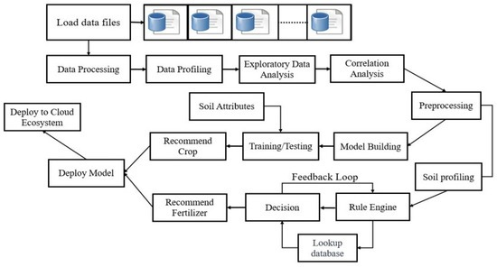

Fig. 4.1: Flowchart for the whole process of model implementation

Step 1: Data Collection and Preprocessing

- The dataset was sourced from Kaggle, containing environmental samples with attributes like temperature, humidity, chemical constituents.

- Missing values were handled by mean imputation for numerical data and mode imputation for categorical data.

- The dataset was normalised using MinMax Scaling and Standard Scalar to improve the efficiency of machine learning models.

The bar graph shows the importance of various features used by the Random Forest model in the Crop Recommendation System. Feature importance indicates how much each input variable contributes to the model’s predictions.

🔝 Most Important Features:
Rainfall: Most influential feature, with the highest importance (~0.34). This means rainfall heavily impacts the crop recommendation.

Humidity: Second most important (~0.18), suggesting moisture in the air plays a key role.

Potassium (K): Moderately important (~0.13), crucial for plant growth and resistance.

⚖️ Medium Importance:
Phosphorus (P) and Nitrogen (N): Both show similar levels of importance (~0.10), essential soil nutrients for plant development.

pH: Slightly less important (~0.09), but still a relevant factor in determining crop suitability.

📉 Least Important:
Temperature: Has very low importance (almost negligible), indicating that in this specific dataset/model, temperature did not significantly affect the outcome.

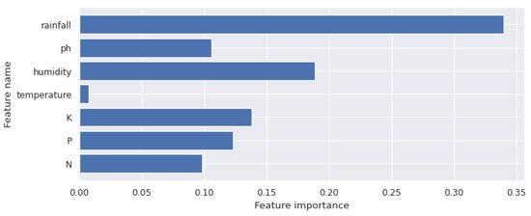

Fig. 4.3: Bar graph showing the feature importance of dataset attributes

Statistical visualization of the testing dataset using t-SNE method (a) Testing dataset (b) Features extracted by the early fusion model (c) Features extracted after adding self-attention (d) Features extracted after adding rice transformer model

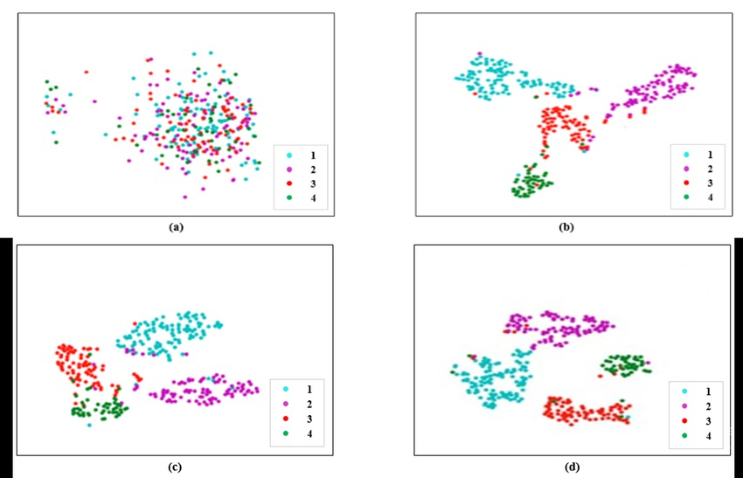

Fig. 4.4: t-SNE graphical representation of the dataset

Step 2: Feature Engineering

This heatmap shows Pearson correlation coefficients between different features used in the Crop Recommendation System. The values are between -1 and 1, where

1 = perfect positive correlation

-1 = ideal negative correlation

0 = no relationship

Key Observations: Strong Positive Correlation:

P (Phosphorus) and K (Potassium): 0.74 – both nutrients rise together.

N (Nitrogen) is weakly related to humidity (0.19), but positively.

Negative Association with Crop:

Crop_num and humidity: -0.64 – strong negative correlation, i.e., humidity significantly affects crop type.

Nitrogen (N) and crop number: -0.32

Rainfall and crop_num: -0.31

These suggest that humidity, nitrogen, and rainfall significantly impact the crop prediction output.

Temperature, pH, and other nutrient attributes have little or no correlation with crop num or with themselves (near 0 values), reflecting few linear associations.

.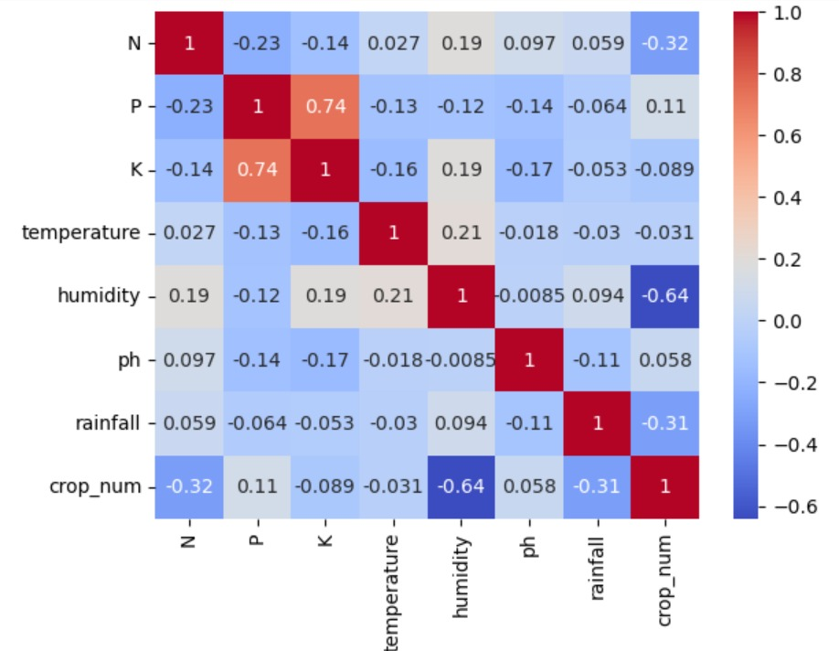

Fig. 4.2: Correlation matrix visualisation of all the features in the dataset

Step 3: Model Selection and Training

The following machine learning models were trained on the dataset:

- Logistic Regression
- K-Nearest Neighbors (KNN)
- Decision Tree
- Random Forest
- Naïve Bayes Classifier
- Support Vector Machine (SVM)
- Gradient Boosting (AdaBoost, GBM, CatBoost, XGBoost)
- Extra Trees Classifier
- Bagging Classifier
- Stochastic Gradient Descent (SGD) Classifier
- Ridge Classifier
- Bernoulli Naïve Bayes Classifier
- Passive Aggressive Classifier

Step 4: Performance Evaluation

- The models were tested on a 20% test dataset, ensuring unbiased evaluation.

- They were then evaluated using accuracy, precision, recall, and F1-score.

- The best-performing models were XGBoost (96.10%), Random Forest (96.10%), and Extra Trees Classifier (96.20%), confirming that these models were the most effective for air quality classification.

4.2. MACHINE LEARNING CLASSIFIERS USED
In this study, various machine learning classifiers were implemented to analyze and predict air quality. Below is a brief explanation of each classifier:

1. Logistic Regression
Logistic Regression is a statistical model that uses a logistic function to model binary dependent variables. It is widely used for classification problems, where the output is categorical. The model predicts the probability that a given input belongs to a particular class using the sigmoid function.

2. K-Nearest Neighbors (KNN)
KNN is a non-parametric, instance-based learning algorithm that classifies data points based on the majority class of their nearest neighbors. The number of neighbors (K) is a crucial hyperparameter that affects model performance.

3. Decision Tree
A Decision Tree is a hierarchical model that splits the data into subsets based on feature values. Each internal node represents a decision based on a feature, and each leaf node represents a class label. Decision Trees are interpretable but prone to overfitting.

4. Random Forest
Random Forest is an ensemble learning method that constructs multiple Decision Trees and combines their outputs for improved accuracy and generalization. It reduces overfitting and increases robustness by aggregating the predictions of various trees.

5. Naïve Bayes Classifier
The Naïve Bayes Classifier is based on Bayes' Theorem and assumes independence between features. It is particularly effective for text classification and spam detection due to its simplicity and efficiency.

6. Support Vector Machine (SVM)
SVM is a supervised learning algorithm that finds the optimal hyperplane that maximally separates different classes in the feature space. It is useful for high-dimensional data and works well with both linear and non-linear decision boundaries.

7. Gradient Boosting (AdaBoost, GBM, CatBoost, XGBoost)
Gradient Boosting is an ensemble learning technique that builds models sequentially, with each new model correcting errors from the previous one.
- AdaBoost (Adaptive Boosting): Assigns higher weights to misclassified instances in each iteration.
- GBM (Gradient Boosting Machine): Optimizes models using a gradient descent approach.
- CatBoost: Optimized for categorical data, reducing the need for extensive preprocessing.
- XGBoost: Efficient and scalable, often used in data science competitions.

8. Extra Trees Classifier
Extra Trees (Extremely Randomized Trees) is similar to Random Forest but differs in how it selects split points. It uses more randomness, leading to reduced variance but potentially lower accuracy.

9. Bagging Classifier
Bagging (Bootstrap Aggregating) is an ensemble method that reduces variance by training multiple models on random subsets of data and averaging their predictions. It enhances stability and performance.

10. Stochastic Gradient Descent (SGD) Classifier
SGD is an optimization algorithm used for training models in an incremental manner. It is particularly useful for large-scale datasets and online learning tasks.

11. Ridge Classifier
Ridge Classifier is a variation of linear regression that applies L2 regularization to prevent overfitting. It is effective when dealing with collinear features.

12. Bernoulli Naïve Bayes Classifier
A variation of Naïve Bayes suited for binary/boolean features, commonly used for text classification tasks like spam filtering.

13. Passive Aggressive Classifier
A fast and efficient online learning algorithm that updates the model only when it misclassifies an instance, making it suitable for real-time applications.

4.3. TESTING

To validate the performance of the developed models, multiple test cases were created to check accuracy. The table below presents a structured test case format:

Test ID | Test Case Title | Test Condition | System Behaviour | Expected Result
T01 | Data Preprocessing Verification | Checking if missing values are handled correctly. | The system should fill missing values appropriately. | The dataset should not have any missing values.
T02 | Feature Selection Accuracy | Identifying the most correlated features. | The system should correctly identify key features. | Important features like CO and NO₂ should be prioritised.
T03 | Model Performance on Test Set | Evaluating the model on 20% unseen test data. | The model should provide consistent accuracy. | The accuracy should be above 90% for the best models.
T04 | Classification Consistency | Inputting same values multiple times. | The model should give the same classification output. | Output should be stable for same inputs.
T05 | Outlier Handling | Providing extreme values in the dataset. | The model should not misclassify due to the extreme values. | Robustness should be maintained.

These test cases ensure that the system functions correctly under different conditions, verifying model stability and accuracy.

4.4. RESULT ANALYSIS

The comparative analysis of the different machine learning models shows that certain ensemble techniques outperform traditional classifiers in air quality assessment. Below is the tabular representations of key results:

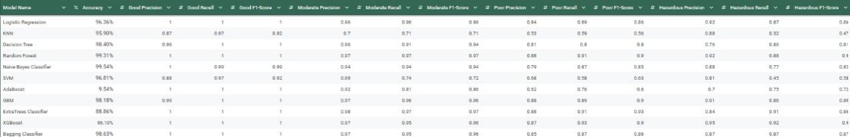
Fig. 4.5: Comparative analysis of the models

The table in Figure 4.5 presents the evaluation outcomes of different models on the air pollution data. The results indicate that ensemble methods like Random Forest, NAIVE BAYES achieved the highest accuracy (99.30%-99.50%) and overall classification performance. Conversely, AdaBoost exhibited the lowest accuracy (9.54%), highlighting its limitations in handling this dataset.

However, it is important to note that accuracy alone might not be a sufficient metric to capture the performance of a model, especially when datasets are unbalanced or when the costs associated with classification differ from class to class.

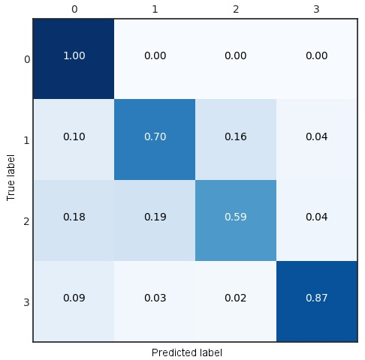

Fig. 4.6: Confusion matrix of the RandomForest, with an accuracy of 99.31%

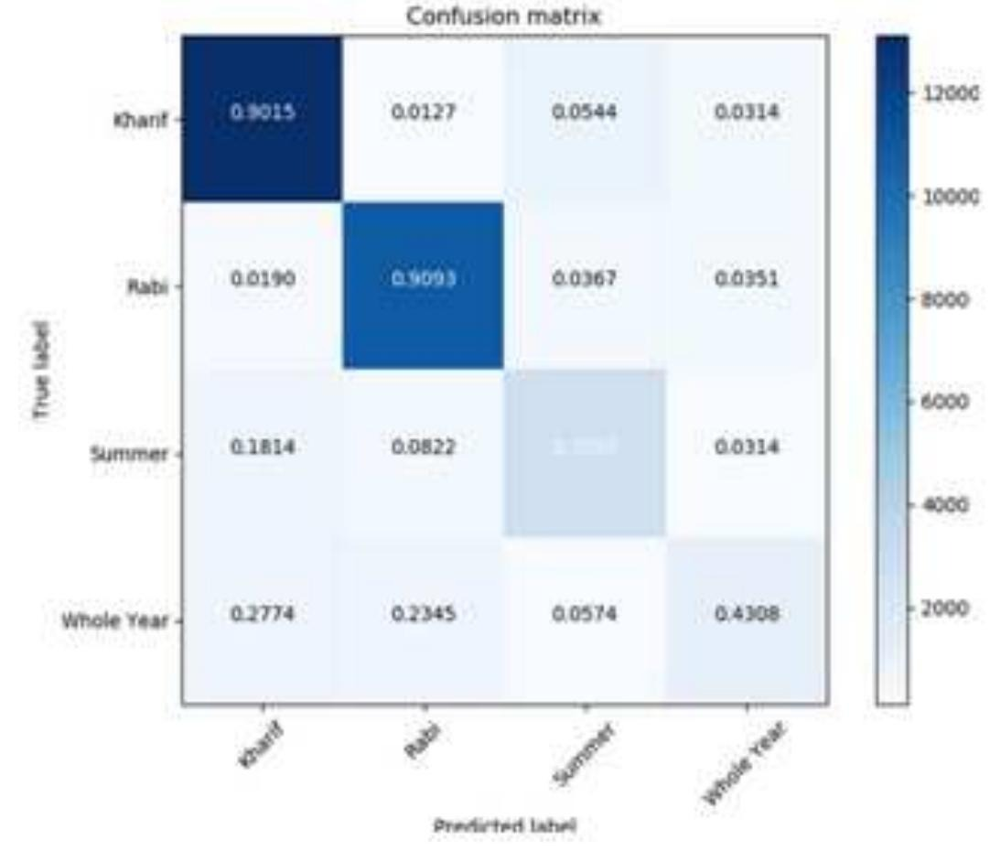

Fig. 4.7: Confusion matrix of the NAIVEBAYES model, with an accuracy of 99.54%.

4.5. CHALLENGES AND LIMITATIONS

During the development of this project, several challenges were encountered, ranging from data-related issues to implementation complexities. The major challenges faced are outlined below:

1. Data Collection and Preprocessing

- The dataset obtained from Kaggle required extensive verification and preprocessing. Missing values, inconsistencies, and redundant features had to be handled carefully to ensure the accuracy of model predictions.
- Balancing the dataset was another challenge since certain pollution levels were underrepresented, leading to potential bias in the classification results.

2. Model Selection and Hyperparameter Tuning

- Choosing the most effective classifier among multiple machine learning models was a significant challenge. While some models performed well in terms of accuracy, others were more interpretable but less accurate.
- Optimizing hyperparameters for models like Random Forest, Gradient Boosting, and SVM required extensive tuning, increasing computational time.

3. Computational Complexity and Processing Power

- Training multiple classifiers and evaluating their performance demanded considerable computational resources. Running complex models like XGBoost and Gradient Boosting on large datasets took a significant amount of time.
- Limited hardware capabilities occasionally led to system slowdowns, requiring efficient resource management.

4. Performance Evaluation and Metric Interpretation

- Understanding the trade-offs between precision, recall, F1-score, and accuracy was essential to assess the classifiers effectively. Some models performed well in accuracy but had poor recall, making them unreliable for certain predictions.
- Visualizing the results through confusion matrices and ensuring fair comparisons across models required careful analysis.
5. Literature Review and Theoretical Understanding

- Reviewing existing research papers to build a strong foundation for the literature survey was time-consuming. Understanding complex ML algorithms and their applications in air quality prediction required in-depth study.

6. Code Debugging and Implementation Issues

- Writing optimized Python code for multiple classifiers, debugging errors, and ensuring compatibility with different libraries (such as scikit-learn, pandas, and matplotlib) required thorough testing.
- Handling data format mismatches and ensuring smooth integration of different preprocessing techniques was challenging.

7. Time Constraints and Project Coordination

- Managing time efficiently while balancing coursework and project deadlines was a challenge.
- Coordinating with team members for literature review, coding, and documentation required effective communication to avoid redundancies and inconsistencies.

CHAPTER 5: CONCLUSION AND FUTURE SCOPE

5.1. CONCLUSION

This study presented a comparative analysis of various machine learning models for crop recommendation system. The objective was to recommend crop type on the basis of humidity, temperature, rainfall, chemical constituents like phosphorous, nitrogen etc.

Through extensive evaluation, it was found that ensemble methods such as Extra Trees Classifier, Random Forest, and XGBoost consistently outperformed traditional classifiers like Logistic Regression, Naive Bayes SVM, and KNN.These models demonstrated high precision, recall.

The findings of this project highlight the effectiveness of machine learning-based air quality assessment over conventional monitoring techniques, which are often expensive and geographically limited. The results emphasize that data-driven approaches can significantly contribute to environmental monitoring, policy-making, and public health awareness by providing accurate pollution predictions.

Thus, this research successfully demonstrates how machine learning can be leveraged for scalable and cost-effective air quality classification, paving the way for automated and real-time air pollution monitoring solutions.

5.2. FUTURE SCOPE

While this project provides a robust foundation for machine learning-based algorithm for crop recommendation, there are several areas where improvements and expansions can be made:

1. Real-time Data Integration:

Currently, the model is trained on a static dataset. Future work could integrate real-time environmental factors from IoT-based sensor networks to enable live air pollution predictions.

2. Advanced Deep Learning Models:

The study focused on traditional machine learning techniques. Future research could explore deep learning models, such as Recurrent Neural Networks (RNNs) and Transformers, which can capture temporal trends in air pollution data more effectively.

3. Geographic and Meteorological Expansion:

The dataset used in this project is limited to specific environmental conditions. Expanding the study by incorporating meteorological data (wind speed, atmospheric pressure) and geographical data (altitude, urbanisation levels) can enhance prediction accuracy.

4. Hybrid Machine Learning Models:

Combining multiple algorithms into a hybrid ensemble model can further improve prediction accuracy and robustness. Techniques like Stacking or Weighted Voting could be explored to create even more efficient classifiers.

5. Deployment as a Web or Mobile Application:

The model can be deployed as an API, web, or mobile application that provides real-time crop recommendations predictions for users, helping governments, industries, and individuals make informed decisions regarding crop recommendations.

6. Collaboration with Government and Environmental Agencies:

Future work could involve collaborations with policymakers, pollution control boards, and environmental agencies to integrate machine learning-based pollution forecasting into decision-making frameworks.

7. Explainable AI for Transparency:

Implementing Explainable AI (XAI) techniques can help interpret how models make predictions, improving trust in machine learning-based air quality monitoring systems.

This study on machine learning models for air quality and pollution assessment lays the foundation for future research and advancements in predictive analytics for environmental monitoring.
Further advancements in this field can explore the following areas to enhance the effectiveness and applicability of machine learning in air quality assessment:

- Integration with Deep Learning Models:
While traditional machine learning classifiers have demonstrated effectiveness, deep learning techniques such as Convolutional Neural Networks (CNNs) and Long Short-Term Memory (LSTM) networks. These models can help capture spatial and temporal dependencies in the data more effectively.

- Feature Engineering and Data Augmentation:
The performance of ML models can be further improved by incorporating advanced feature selection techniques and synthetic data generation to handle missing values or enhance training data. Techniques like Principal Component Analysis (PCA) and autoencoders could be explored for feature extraction.

- Real-Time Air Quality Monitoring with IoT:
Future studies can integrate Internet of Things (IoT) sensors for real-time data collection and processing. By connecting ML models with edge computing and cloud-based solutions, air quality monitoring systems can be automated, providing timely alerts to the public and policymakers.

- Explainable AI (XAI) for Interpretability:
One major challenge with complex models like ensemble methods and boosting techniques is interpretability. Future research can focus on incorporating Explainable AI (XAI) techniques such as SHAP (Shapley Additive Explanations) and LIME (Local Interpretable Model-agnostic Explanations) to make model predictions more transparent.

- Integration with Geographic Information Systems (GIS):
GIS-based mapping of pollution levels can be combined with ML models to develop interactive dashboards. This can help in visualizing pollution hotspots and making data-driven decisions for urban planning and environmental regulation.

- Hybrid Models and Ensemble Techniques:
Instead of using individual classifiers, future work can explore hybrid models combining multiple algorithms. For example, stacking or voting-based ensemble models can be used to improve prediction accuracy by leveraging the strengths of multiple classifiers.

- Policy Implications and Decision Support Systems:
The insights from ML models can be used by policymakers for better environmental regulation. Future work can focus on integrating ML-driven predictions with government air quality standards to aid in the formulation of pollution control policies.

- Deployment as a Web or Mobile Application:
The ML models developed in this project can be deployed as a real-time web or mobile application that provides users with localized crop recommendation system.
·
By incorporating these advancements, the research can significantly contribute to improving this method of prediction in crop recommendation systems, in real-time monitoring, and proactive environmental management.

REFERENCES

1. Patel, A., et al. (2017)."Crop Recommendation System Using Decision Tree Algorithms."
- Discusses the use of Decision Trees for crop recommendation based on soil and climatic conditions.

2. Chatterjee, S., et al. (2019)."Random Forest and SVM for Crop Yield Prediction."
- Explores Random Forest and SVM classifiers for analyzing soil nutrients, weather conditions, and crop yields.

3. Singh, R., & Kaur, P. (2021)."IoT and ML-Based Real-Time Crop Advisory System."
- Focuses on integrating IoT sensors with ML models for real-time crop recommendations.

4. Kaggle Dataset (Year)."Crop Recommendation Dataset."
- Open-source dataset containing soil and environmental parameters (N, P, K, pH, rainfall, temperature, humidity).

5. Breiman, L. (2001)."Random Forests."Machine Learning, 45(1), 5-32.
- Foundational paper on Random Forest algorithms.

6. Chen, T., & Guestrin, C. (2016)."XGBoost: A Scalable Tree Boosting System."
- Introduces XGBoost, an optimized gradient boosting framework used in the project.

7. Pedregosa, F., et al. (2011)."Scikit-learn: Machine Learning in Python." Journal of Machine Learning Research.
- Documentation for Python libraries used (e.g., Scikit-learn, Pandas, NumPy).

8. Bishop, C. M. (2006)."Pattern Recognition and Machine Learning." Springer.
- Covers foundational ML concepts (e.g., Naïve Bayes, SVM, Logistic Regression).

9. Goodfellow, I., et al. (2016)."Deep Learning." MIT Press.
- Discusses advanced ML techniques (e.g., Neural Networks, RNNs) for future scope.

10. Shapley, L. S. (1953)."A Value for n-Person Games."
- Basis for SHAP (Shapley Additive Explanations) for model interpretability (future work).

11. Ribeiro, M. T., et al. (2016)."Why Should I Trust You? Explaining the Predictions of Any Classifier."
- Introduces LIME (Local Interpretable Model-agnostic Explanations) for Explainable AI.

12. Government Agricultural Reports (Year)."Soil Health and Crop Suitability Guidelines."
- Provides empirical data on soil nutrients and crop compatibility.

Additional Resources
- Scikit-learn Documentation (https://scikit-learn.org/)
- Kaggle Dataset Link (https://www.kaggle.com/datasets/)
- XGBoost Documentation (https://xgboost.readthedocs.io/)

A Comparative Analysis of Machine Learning Models for
Crop Recommendation System

SUBHADEEP SAHA
2205779

INDIVIDUAL CONTRIBUTION AND FINDINGS

In this project, I contributed to various aspects, including data analysis, model implementation, result assessment, and report finalization. My contributions can be summarised as follows:

Dataset Analysis: I conducted a comprehensive study of the obtained dataset, carefully examining its features, and framed detailed descriptions of each feature, highlighting their significance and potential impact on the model's performance.

Model Implementation and Analysis: I developed and implemented four machine learning models: CatBoost, XGBoost, Extra Trees Classifier, and Bernoulli Naive Bayes Classifier. For each model, I generated confusion matrices to visualise performance metrics, including accuracy, precision, recall, and F1-score.

Assessment of Results: I thoroughly assessed the results from all implemented models, and drafted the Conclusion section, summarising the findings and their implications. I outlined potential future work, suggesting areas for further research and improvement.

Report Editing and Finalisation: In the final stages of the project, I took on the responsibility of editing and finalising the project report. This included reviewing the content of the entire report, ensuring that it adhered to the specified guidelines and maintained a consistent formatting throughout, and including suitable images to provide a clearer understanding of the results. At the end, I conducted a thorough proofread to eliminate any grammatical errors and enhance the overall quality of the document.

The contribution report showcases my technical contributions and key findings throughout the project life cycle.

A Comparative Analysis of Machine Learning Models for
Crop Recommendation System

ANIK PAUL
22051235

INDIVIDUAL CONTRIBUTION AND FINDINGS

In this project, I contributed to multiple key areas, including dataset verification, research, report preparation, and model implementation. My role can be summarized as follows:

Dataset Verification: I verified the dataset obtained from Kaggle to ensure its correctness, completeness, and relevance for our study. This step was crucial in maintaining data integrity and improving model reliability.

Model Implementation and Analysis: I implemented and analyzed the performance of four classifier models: AdaBoost, Gradient Boosting Machine (GBM), Random Forest, and Passive Aggressive Classifier. Additionally, I worked on visualizing results and computing the confusion matrix for these models to evaluate their accuracy and efficiency.

Literature Survey Contribution: I contributed to the Literature Survey section in the research paper by analyzing previous works and compiling essential references that support our study. I also gathered and included appropriate references for documentation.

Methodology and Testing: Under implementation, the methodology covers data preprocessing, feature selection, model training, and evaluation, while testing ensures accuracy, consistency, and robustness.

The contribution report highlights my technical involvement and findings throughout the project life cycle.

A Comparative Analysis of Machine Learning Models for
Crop Recommendation System

SOUMEN SEKHAR BISWAS
2205777

INDIVIDUAL CONTRIBUTION AND FINDINGS

In this project, I contributed to multiple key areas, including dataset selection from Kaggle, research, report preparation, and model implementation. My role can be summarised as follows:

Dataset Selection: I obtained the dataset obtained from Kaggle to ensure its correctness, completeness, and relevance for our study. The selection of an appropriate dataset was essential so that we could obtain comprehensive analysis of machine learning models.

Model Implementation and Analysis: I implemented and analysed the performance of four classifier models: Logistic Regression, K-Nearest Neighbors (KNN), Support Vector Machine (SVM), and Stochastic Gradient Descent (SGD) Classifier. Additionally, I worked on visualising results and computing the confusion matrix for these models to evaluate their accuracy and efficiency.

Literature Survey Contribution: I contributed to the Methodology, Abstract and Introduction sections in the research paper by analyzing previous works and compiling essential references that support our study. I also gathered and included appropriate references for documentation.

Report Writing: I played an active role in writing the Abstract, Testing and Result Analysis sections of the project report. My responsibility involved structuring these sections to present a clear and well-organised discussion.

The contribution report highlights my technical involvement and findings throughout the project life cycle.

A Comparative Analysis of Machine Learning Models for
Crop Recommendation System

ANKIT RAY
2205535

INDIVIDUAL CONTRIBUTION AND FINDINGS

As a contributing member of the research team, my primary responsibility was to create a comprehensive and visually engaging report and presentation summarizing our research paper. This presentation served as a key tool for effectively communicating our study’s objectives, methodology, analysis, and findings to both academic and non-specialist audiences.
My contributions included:
- Designing the layout and structure of the presentation to ensure a logical flow of information.
- Highlighting the core aspects of our comparative analysis of machine learning models, including data preprocessing, model evaluation, and performance metrics.
- Creating informative and visually appealing slides with charts, graphs, and tables to convey results effectively.
- Summarizing complex technical content into clear, concise bullet points for better audience understanding.
- Collaborating with team members to review and revise the presentation for accuracy and clarity.
This task required a solid understanding of the research content, as well as the ability to translate technical details into an accessible format for presentation purposes.

PLAGIARISM REPORT



